In this tutorial, we’ll show how we used clean_anomalies() from the anomalize package to ***reduce forecast error by 9%.***

**R Packages Covered**:

* anomalize – Time series anomaly detection

**Cleaning Anomalies to Reduce Forecast Error by 9%**

We can often improve forecast performance by cleaning anomalous data prior to forecasting. This is the perfect use case for integrating the clean_anomalies() function from anomalize into your ***forecast workflow***.

**Forecast Workflow**

We’ll use the following workflow to remove time series anomalies prior to forecasting.

1. **Identify the anomalies** – Decompose the time series with time_decompose() and anomalize() the remainder (residuals)
2. **Clean the anomalies** – Use the new clean_anomalies() function to reconstruct the time series, replacing anomalies with the trend and seasonal components
3. **Forecast** – Use a forecasting algorithm to predict new observations from a training set, then compare to test set with and without anomalies cleaned

**Step 1 – Load Libraries**

First, load the following libraries to follow along.

library(tidyverse) # Core data manipulation and visualization libraries

library(tidyquant) # Used for business-ready ggplot themes

library(anomalize) # Identify and clean time series anomalies

library(timetk) # Time Series Machine Learning Features

library(knitr) # For kable() function

**Step 2 – Get the Data**

This tutorial uses the tidyverse_cran_downloads dataset that comes with anomalize. These are the historical downloads of several “tidy” R packages from 2017-01-01 to 2018-03-01.

Let’s take one package with some extreme events. We’ll hone in on lubridate (but you could pick any).

tidyverse_cran_downloads %>%

time_decompose(count) %>%

anomalize(remainder) %>%

time_recompose() %>%

plot_anomalies(ncol = 3, alpha_dots = 0.3)

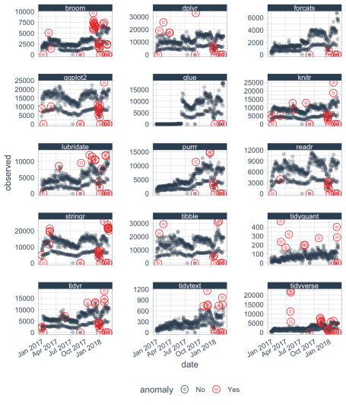

We’ll filter() downloads of the lubridate R package.

lubridate_tbl <- tidyverse_cran_downloads %>%

ungroup() %>%

filter(package == "lubridate")

Here’s a visual representation of the forecast experiment setup. Training data will be any data before “2018-01-01”.

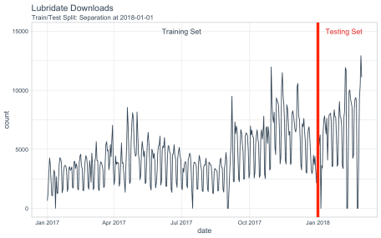

**Step 3 – Workflow for Cleaning Anomalies**

The workflow to clean anomalies:

1. We decompose the “counts” column using time_decompose() – This returns a Seasonal-Trend-Loess (STL) Decomposition in the form of “observed”, “season”, “trend” and “remainder”.
2. We fix any negative values – If present, they can throw off forecasting transformations (e.g. log and power transformations)
3. We identifying anomalies (anomalize()) on the “remainder” column – Returns “remainder_l1” (lower limit), “remainder_l2” (upper limit), and “anomaly” (Yes/No).
4. We use the function, **clean_anomalies()**, to add new column called “observed_cleaned” that ***repairs the anomalous data*** by replacing all anomalies with the trend + seasonal components from the decompose operation.

lubridate_anomalized_tbl <- lubridate_tbl %>%

# 1. Decompose download counts and anomalize the STL decomposition remainder

time_decompose(count) %>%

# 2. Fix negative values if any in observed

mutate(observed = ifelse(observed < 0, 0, observed)) %>%

# 3. Identify anomalies

anomalize(remainder) %>%

# 4. Clean & repair anomalous data

clean_anomalies()

# Show change in observed vs observed_cleaned

lubridate_anomalized_tbl %>%

filter(anomaly == "Yes") %>%

select(date, anomaly, observed, observed_cleaned) %>%

head() %>%

kable()

| **date** | **anomaly** | **observed** | **observed_cleaned** |
| --- | --- | --- | --- |
| 2017-01-12 | Yes | 0 | 3522.194 |
| 2017-04-19 | Yes | 8549 | 5201.716 |
| 2017-09-01 | Yes | 0 | 4136.721 |
| 2017-09-07 | Yes | 9491 | 4871.176 |
| 2017-10-30 | Yes | 11970 | 6412.571 |
| 2017-11-13 | Yes | 10267 | 6640.871 |

Here’s a visual of the “observed” (uncleaned) vs the “observed_cleaned” (cleaned) training sets. We’ll see what influence these anomalies have on a forecast regression (next).

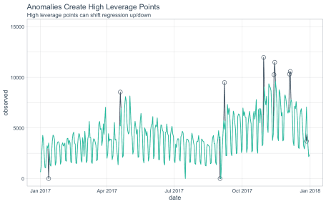

**Step 4 – Forecasting Downloads of the Lubridate Package**

First, we’ll make a function, forecast_downloads(), that can take the input of both cleaned and uncleaned anomalies and return the forecasted downloads versus actual downloads.

**Step 4.1 – Before Cleaning with anomalize**

We’ll first perform a forecast without cleaning anomalies (high leverage points).

* The forecast_downloads() function trains on the “observed” (uncleaned) data and returns predictions versus actual.
* Internally, a power transformation (square-root) is applied to improve the forecast due to the multiplicative properties.
* The model uses a linear regression of the form sqrt(observed) ~ numeric index + year + quarter + month + day of week.

lubridate_forecast_with_anomalies_tbl <- lubridate_anomalized_tbl %>%

# See Apendix - Forecast Downloads Function

forecast_downloads(

col_train = observed, # First train with anomalies included

sep = "2018-01-01", # Separate at 1st of year

trans = "sqrt" # Perform sqrt() transformation

)

**Forecast vs Actual Values**

The forecast is overplotted against the actual values.

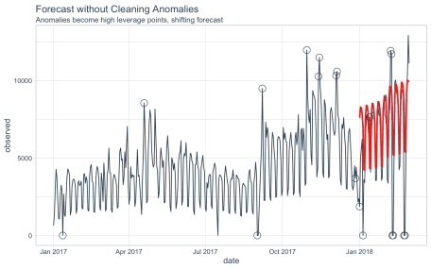

We can see that the forecast is shifted vertically, an effect of the high leverage points.

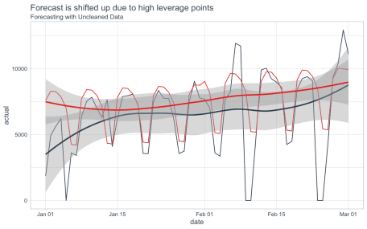

**Forecast Error Calculation**

***The mean absolute error (MAE) is 1570***, meaning on average the forecast is off by 1570 downloads each day.

lubridate_forecast_with_anomalies_tbl %>%

summarise(mae = mean(abs(prediction - actual)))

## # A tibble: 1 x 1

## mae

##

## 1 1570.

**Step 4.2 – After Cleaning with anomalize**

We’ll next perform a forecast this time using the repaired data from clean_anomalies().

* The forecast_downloads() function trains on the “observed_cleaned” (cleaned) data and returns predictions versus actual.
* Internally, a power transformation (square-root) is applied to improve the forecast due to the multiplicative properties.
* The model uses a linear regression of the form sqrt(observed_cleaned) ~ numeric index + year + quarter + month + day of week

lubridate_forecast_without_anomalies_tbl <- lubridate_anomalized_tbl %>%

# See Appendix - Forecast Downloads Function

forecast_downloads(

col_train = observed_cleaned, # Forecast with cleaned anomalies

sep = "2018-01-01", # Separate at 1st of year

trans = "sqrt" # Perform sqrt() transformation

)

**Forecast vs Actual Values**

The forecast is overplotted against the actual values. The cleaned data is shown in Yellow.

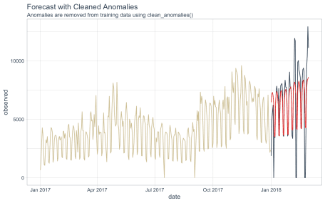

Zooming in on the forecast region, we can see that the forecast does a better job following the trend in the test data.

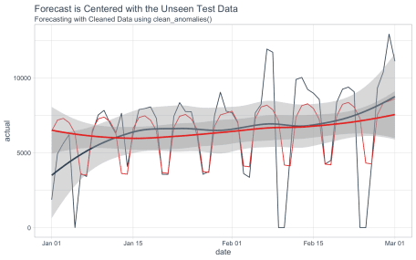

**Forecast Error Calculation**

***The mean absolute error (MAE) is 1435***, meaning on average the forecast is off by 1435 downloads each day.

lubridate_forecast_without_anomalies_tbl %>%

summarise(mae = mean(abs(prediction - actual)))

## # A tibble: 1 x 1

## mae

##

## 1 1435.

**8.6% Reduction in Forecast Error**

Using the new anomalize function, clean_anomalies(), prior to forecasting results in an **8.6% reduction in forecast error** as measure by Mean Absolute Error (MAE).

((1435 - 1570) / 1570)

## [1] -0.08598726

**Conclusion**

Forecasting with clean anomalies is a good practice that can provide **substantial improvement to forecasting accuracy by removing high leverage points**. The new clean_anomalies() function in the anomalize package provides an easy workflow for removing anomalies prior to forecasting.

**Appendix – Forecast Downloads Function**

The forecast_downloads() function uses the following procedure:

* Split the data into training and testing data using a date specified using the sep argument.
* Apply a statistical transformation: none, log-1-plus (log1p()), or power (sqrt())
* Model the daily time series of the training data set from observed (demonstrates no cleaning) or observed and cleaned (demonstrates improvement from cleaning). Specified by the col_train argument.
* Compares the predictions to the observed values.

forecast_downloads <- function(data, col_train,

sep = "2018-01-01",

trans = c("none", "log1p", "sqrt")) {

predict_expr <- enquo(col_train)

trans <- trans[1]

# Spit into training/testing sets

train_tbl <- data %>% filter(date < ymd(sep))

test_tbl <- data %>% filter(date >= ymd(sep))

# Apply Transformation

pred_form <- quo_name(predict_expr)

if (trans != "none") pred_form <- str_glue("{trans}({pred_form})")

# Make the model formula

model_formula <- str_glue("{pred_form} ~ index.num + half

+ quarter + month.lbl + wday.lbl") %>%

as.formula()

# Apply model formula to data that is augmented with time-based features

model_glm <- train_tbl %>%

tk_augment_timeseries_signature() %>%

glm(model_formula, data = .)

# Make Prediction

suppressWarnings({

# Suppress rank-deficit warning

prediction <- predict(model_glm, newdata = test_tbl %>%

tk_augment_timeseries_signature())

actual <- test_tbl %>% pull(!! actual_expr)

})

if (trans == "log1p") prediction <- expm1(prediction)

if (trans == "sqrt") prediction <- ifelse(prediction < 0, 0, prediction)^2

# Return predictions and actual

tibble(

date = tk_index(test_tbl),

prediction = prediction,

actual = observed

)

}